Открытый урок-проект
по английскому языку
в 8 «а» классе
на тему: «Англоговорящие страны»

.
Цели:
Обучающие:
- Формирование умения воспринимать иноязычную речь на слух с извлечением необходимой информации.
- Совершенствование лексических навыков.
- Формирование умений поискового чтения
- Расширение кругозора уч-ся об англо-говорящих странах
Развивающие:
- Развитие познавательной активности учащихся.
- Развитие навыков работы в группе, в сотрудничестве.
- Совершенствование навыков исследовательских методов работы на уроке.
Воспитывающие:
- Развитие чувства ответственности за совместную работу.
- Прививать навыки работы в коллективе.
Вид урока. Комбинированный урок.
Форма урока. Урок с использованием развивающих технологий и технологии обучения в сотрудничестве.
Формы организации познавательной деятельности учащихся на уроке: Групповая, парная, фронтальная.
Оборудование.
- Компьютер, аудиозапись на СD МР3.
- Раздаточный материал с вопросами для каждой группы.
- Политическая карта мира с обозначением англоговорящих стран.
- Плакат с флагами и эмблемами англоговорящих стран.
- Таблицы с пропущенными графами с названиями стран для каждой группы.
- Таблички-смайлики для оценивания учащимися урока.
Ход урока
1. Организационный момент. Приветствие.
Good morning, children. Nice to see you again. How are you?
(We are fine. Thank you. And how are you?).
I’m fine too. Thank you.
Sit down, please. And let’s begin our lesson.

2. Определение темы урока.
Children, look at the posters in our classroom, read their titles and try to guess the theme of our lesson today, please.
You are right. You see the maps of New Zealand, Canada, Australia, the UK, the USA and the flags of these countries. And what language do people speak in these countries?
You are quite right. They speak English.
And the theme of our lesson is “ENGLISH – SPEAKING COUNTRIES”.
3. Постановка цели урока.
So, today you will learn about the geographical situation of these countries, their capitals, population, official languages, some symbols and some interesting facts.
4. Речевая зарядка.
Now, read after me. Mind the pronunciation of new words, try to translate them.
Emblem, advanced, powerful, north, Canberra, Wellington, south, east, financial, island, to occupy, a maple leaf, to stretch, official.
5 .And now lrt us listen the Hymn Of GB

6.Presentation the projects

7.How well do you know about British?

8. Активизация изученного материала по теме «Англоговорящие страны».
Работа в группах.
We have been learning English for 4 years. I’m sure you know some facts about English-speaking countries. You can use the map. Now let’s divide into three groups and try to answer these questions:
- What English-speaking countries do you know?
- What are their capitals?
- What is the official language of Great Britain?
- What is the official language of the USA?
- What is the second largest country in the world?
- The maple leaf is the official emblem of …. .
- What is one of the most powerful countries in the world?
- What country consists of two islands?
- Which country has the third largest population in the world?
- What is the world’s seventh biggest city?
(После обсуждения в группах учащиеся озвучивают свои варианты)
6. Развитие навыков поискового чтения. Работа в группах.
Let’s read the texts from your books and know what the English-speaking people think about their countries. After that we will check if you were right.

The right answers:
- New Zealand, Canada, Australia, the UK, the USA
- The capital of the UK is London.
The capital of the USA is Washington DC.
The capital of New Zealand is Wellington.
The capital of Australia is Canberra.
The capital of Canada is Ottawa.
- English
- English
- Canada
- Canada
- the USA
- New Zealand
- the USA
- London
7. Физкультминутка.
Up, down, up, down,
Which is the way to London town?
Where? Where? Up in the air,
Close your eyes – and you are there.
8. Активизация навыков аудирования. Заполнение таблицы на соотнесение стран, столиц, национальностей и языков. Парная работа. Взаимоконтроль
Now you will listen to the tape and fill in the gaps in the table. <Приложение 1>
Who has no mistakes? Well done.
9. Закрепление изученной страноведческой информации.
It’s time to find out what you know about English-speaking countries. Read the statements and agree or disagree with them. If the statement is false, correct it, please.
- American English and British English are absolutely the same.
- There are lots of people in the United States who can speak Spanish.
- Canada is famous for its deserts
- There are two official languages in Canada – English and Spanish.
- New Zealand consists of two main islands and some small islands.
- The official languages in New Zealand are English and French.
- The UK is the third largest country in the world.
- Great Britain is an island state.
- Australia occupies the whole continent.
- There is no official language in Australia.
10. Подведение итогов урока. Выставление отметок.
What have you learned about English-speaking countries today?
Thank you, children. You have learned a lot and I give you only good and excellent marks today.

11. Объяснение домашнего задания.
Children, you will continue working on the theme at home. Write down your homework. Prepare the story about one of the English-speaking countries.
12. Впечатления от урока. Выбор смайликов. <Приложение 2>
What is your opinion of the lesson? Choose the badge that reflects your mood. Show us your badges. I am very glad that you have chosen the badges with happy faces. Thank you. Our lesson is over. Good bye.

Приложение 1

Fill in the gaps in the table:
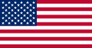

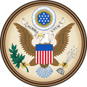

English, Maori
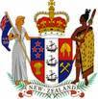
The UK

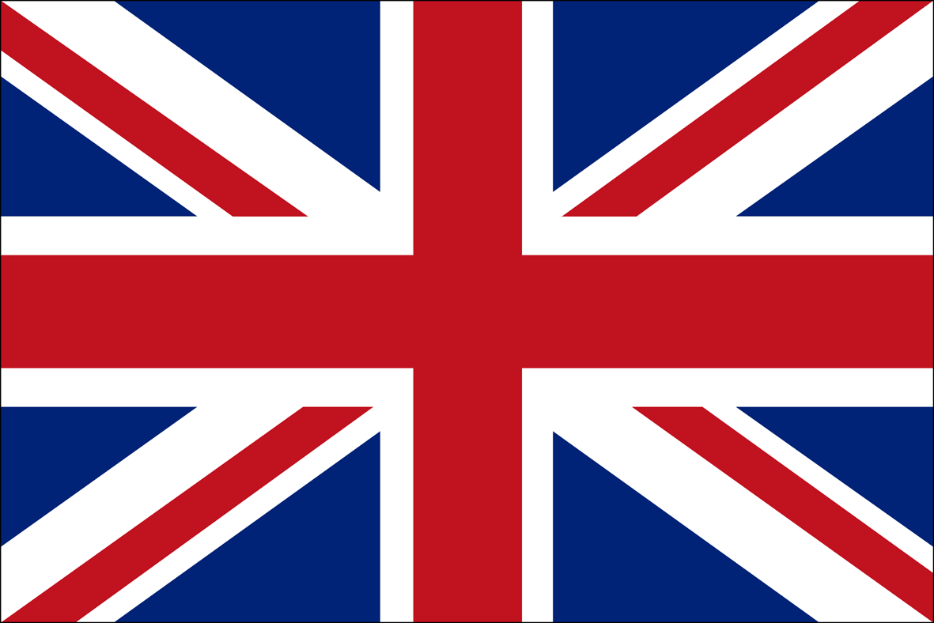

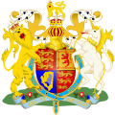

Canberra

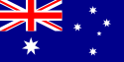

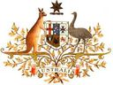

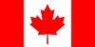

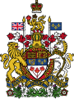

Приложение 2
Значки – смайлики для оценивания урока.
Very good!
Good!

